Different weights for augmentation loss for Gauss VRM, MixUp for three datasets.

Standard training for the three datasets

Two spirals

Aug x:y => x * perturb_loss + y * original_loss

L2 decay 1e-4

Std 0.25

Gauss VRM breast NN augmentation 0.5:0.5 : train 1.00000, test 0.96491 500 epochs lr 0.01

Gauss VRM breast NN perturbation : train 0.99707, test 0.97368 300 epochs lr 0.01

Gauss VRM cifar10 NN augmentation 0.5:0.5 : train 0.97140, test 0.88870 200 epochs lr 0.1

Gauss VRM cifar10 NN perturbation : train 0.96418, test 0.8917 100 epochs lr 0.1

Gauss VRM MNIST NN augmentation 0.5:0.5 : train 0.99997, test 0.99290 100 epochs lr 0.01

Gauss VRM MNIST NN perturbation : train 0.99933, test 0.99310 50 epochs lr 0.01

Mixup NN augmentation vs perturbation BREAST alpha 1.0 lr 0.0025

|  |  |  |
| --- | --- | --- |
|  | train | test |
| Perturbation 300 epochs | 0.97067 | 0.98246 |
| Aug 0.25:0.75 500 epochs | 0.99413 | 0.96053 |
| Aug 0.5:0.5 500 epochs | 0.98534 | 0.97368 |
| Aug 0.75:0.25 500 epochs | 0.98240 | 0.96491 |
| Aug 0.9:0.1 500 epochs | 0.98240 | 0.97807 |
| Aug0.99:0.01 500 epochs | 0.98534 | 0.97807 |

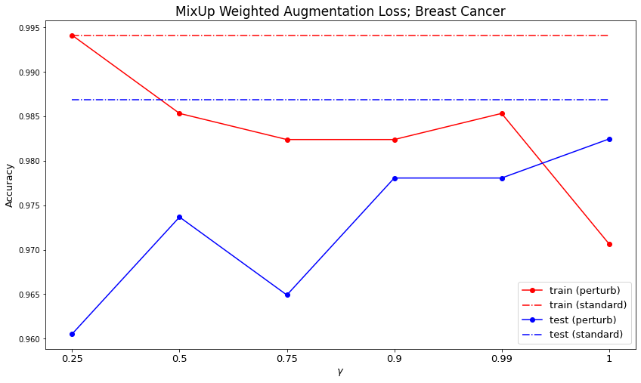

Mixup NN augmentation vs perturbation cifar10 alpha 1.0 lr 0.1

|  |  |  |
| --- | --- | --- |
|  | train | test |
| Perturbation 100 epochs | 0.97667 | 0.91940 |
| Aug 0.25:0.75 200 epochs | 0.97760 | 0.91740 |
| Aug 0.5:0.5 200 epochs | 0.97558 | 0.92000 |
| Aug 0.75:0.25 200 epochs | 0.97600 | 0.92420 |
| Aug 0.9:0.1 200 epochs | 0.96676 | 0.91640 |
| Aug0.99:0.01 200 epochs | 0.96298 | 0.91950 |

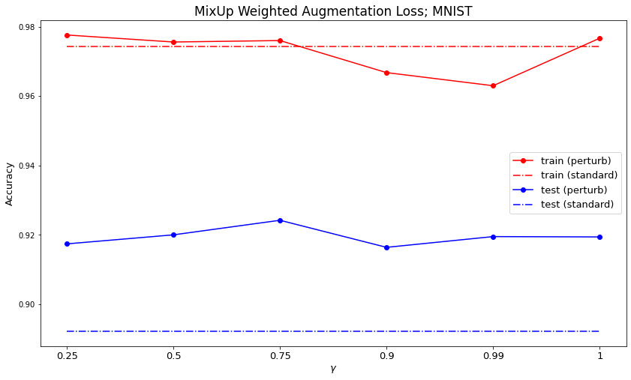

Mixup NN augmentation vs perturbation MNIST alpha 1.0 lr 0.01

|  |  |  |
| --- | --- | --- |
|  | train | test |
| Perturbation 50 epochs | 0.99595 | 0.98970 |
| Aug 0.25:0.75 100 epochs | 0.99997 | 0.99480 |
| Aug 0.5:0.5 100 epochs | 0.99973 | 0.99370 |
| Aug 0.75:0.25 100 epochs | 0.99958 | 0.99440 |
| Aug 0.9:0.1 100 epochs | 0.99980 | 0.99540 |
| Aug0.99:0.01 100 epochs | 0.99942 | 0.99480 |

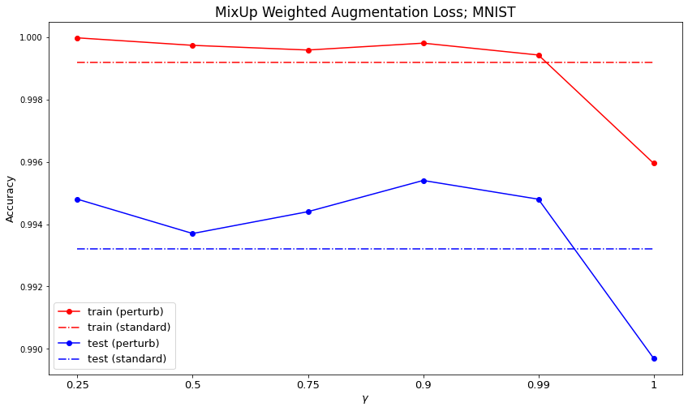

Standard

Breast NN lr 0.005 300 epochs: train 0.99413, test 0.98684

Cifar10 NN lr 0.1 100 epochs: train 0.97420, test 0.89220

MNIST NN lr 0.01 30 epochs: train 0.99917, test 0.99320

FUCKING OLD EXPERIMENTS

NN Gauss VRM Two Spirals Few Data 72 train data hidden 1000, 100 RELU L2REG=0, iter=1000

Standard: train 1.0, test 0.70833

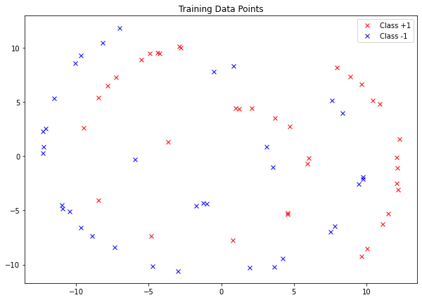

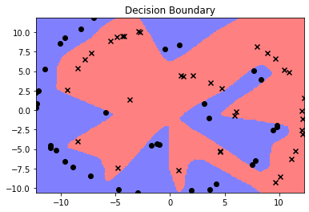

Perturb: train 0.72222 test 0.625

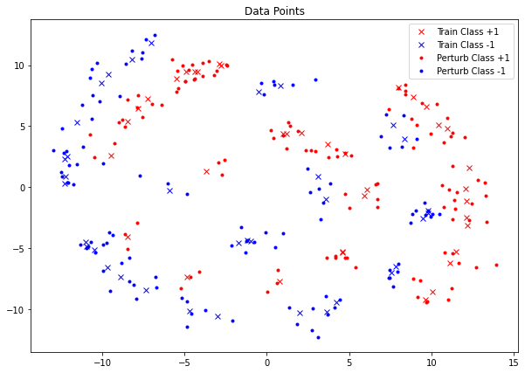

Augment train 0.93056 test 0.66666

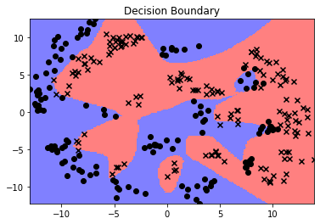

NN Gauss VRM Two Spirals MORE Data 300 train data hidden 1000, 100 RELU L2REG=0, iter=1000

Standard: train 0.97333, test 0.86000

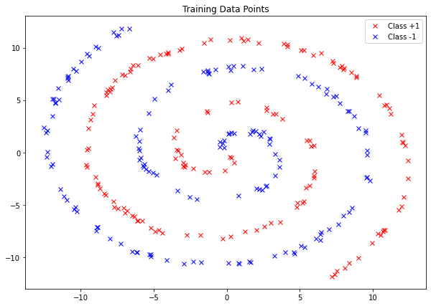

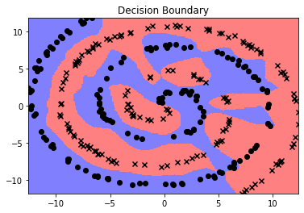

Perturb: train 0.95555 test 1.0

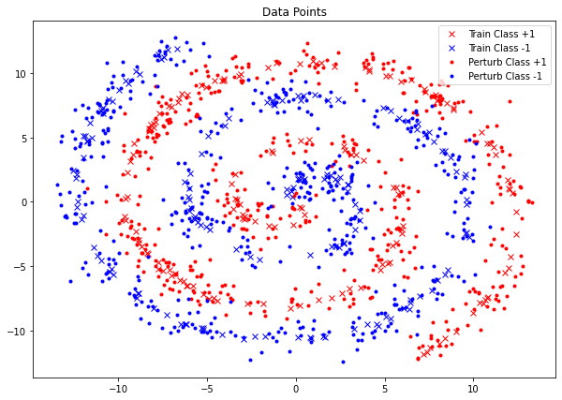

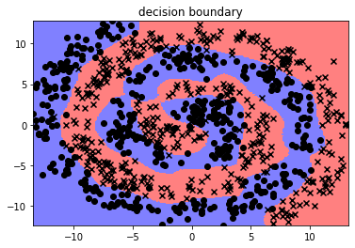

Augment train 0.95 test 0.97

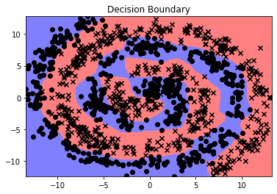

mixup two spirals NB and manifold intrusion NN Few Data 72 train data hidden 1000, 100 RELU L2REG=0, iter=1000 alpha 0.2

standard train 1.0 test 1.0

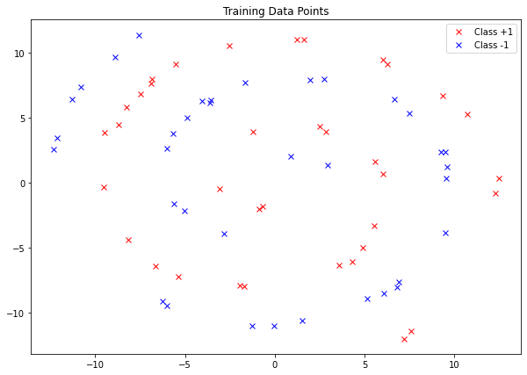

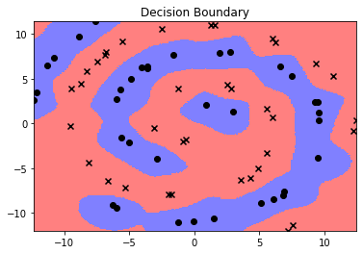

Perturb train 1.0 test 0.70833

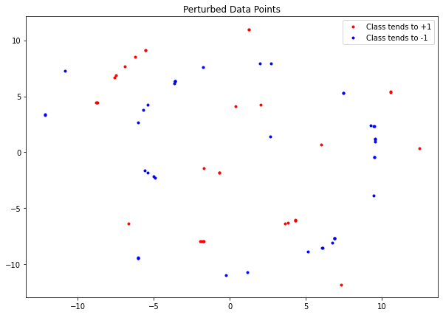

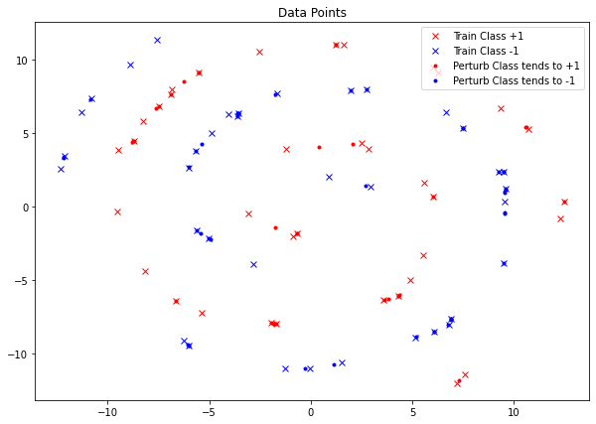

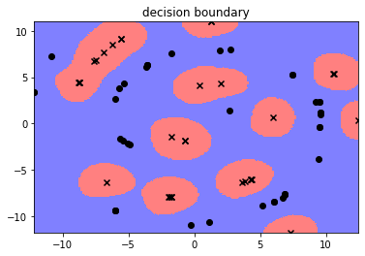

Augment train 1.0 test 1.0

